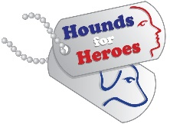 Event Registration Form HQ Ref: ……………………………………
Organiser’s Name:
Organiser’s Address:
Email Address:
Telephone Number:

Name of Event
Date of Event |  | Time of Event
Event Address

JustGiving/Website Links:
(if applicable)
No. of collection Buckets/Boxes/Banners  PLEASE NOTE: Boxes, Buckets and Banners must be returned to the address below after the event | BOXES | BUCKETS | BANNERS

Your personal details will be kept securely on our database. We will send you information that will help with your event. We will not disclose your information to any other person or organisation, except when required to by law or if we believe it is in your ‘vital interests’ to do so - for example, if you were taken ill during the event.
As part of GDPR requirements we need you to indicate by ticking the boxes below that you consent to us retaining your data and contacting you in the future with updates on the charity.
o I give consent for Hounds for Heroes to retain my data.
o I give consent for Hounds for Heroes to contact me with updates on the charity
For Office Use Only
Date Requested |  | Date Despatched |  | Carrier & Cost |  | Date Returned
Funds Received
Date

